Record
# Source: AI Source: Provided by: [Data Path: Persons Table -> ID Column: 1, Name_En Column: Motasem Essam] -> From: [Chatgpt (GPT‑5 Mini)] on [1/26/2026]
In computing and data management, a record is a collection of related data items stored together as a single unit. Think of it like a row in a table in a database or a single “entry” in a file.

Structure:
# Source: AI Source: Provided by: [Data Path: Persons Table -> ID Column: 1, Name_En Column: Motasem Essam] -> From: [Chatgpt (GPT‑5 Mini)] on [1/26/2026]
  - A record is made up of fields (also called attributes).
  - Each field stores one piece of information.
  - Example of a record in a student database:
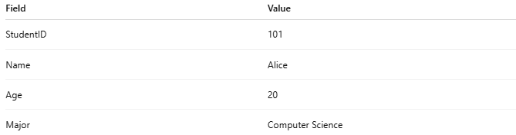
Field | Value
StudentID | 101
Name | Alice
Age | 20
Major | Computer Science
- Here, the entire row is one record, and each column (StudentID, Name, etc.) is a field.

Purpose:
# Source: AI Source: Provided by: [Data Path: Persons Table -> ID Column: 1, Name_En Column: Motasem Essam] -> From: [Chatgpt (GPT‑5 Mini)] on [1/26/2026]
  - Records are used to store structured information so it can be easily retrieved, updated, or processed.

Where You Find Records:
# Source: AI Source: Provided by: [Data Path: Persons Table -> ID Column: 1, Name_En Column: Motasem Essam] -> From: [Chatgpt (GPT‑5 Mini)] on [1/26/2026]
  - Databases: Each row in a table is a record.
  - Files: In a structured file (like CSV or Excel), each line can be a record.
  - Programming: Objects or structs can represent records in memory.

Example in a CSV File:
# Source: AI Source: Provided by: [Data Path: Persons Table -> ID Column: 1, Name_En Column: Motasem Essam] -> From: [Chatgpt (GPT‑5 Mini)] on [1/26/2026]
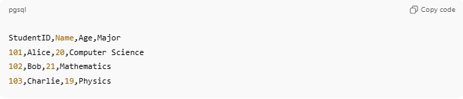
StudentID,Name,Age,Major
101,Alice,20,Computer Science
102,Bob,21,Mathematics
103,Charlie,19,Physics
- Each line after the header is a record.

💡 Analogy:
# Source: AI Source: Provided by: [Data Path: Persons Table -> ID Column: 1, Name_En Column: Motasem Essam] -> From: [Chatgpt (GPT‑5 Mini)] on [1/26/2026]
- File → Like a notebook
- Record → One page in the notebook
- Field → A line or entry on that page

